European Semester - ANED fiche on disability - European Union overview

Synthesis Report
for the
Academic Network of European Disability Experts

Prepared by Mark Priestley
with data provided by the ANED core team and country experts

December 2014

Content

Introduction 2
Executive summary 3
1 Summary of the overall situation and challenges 5
2 Assessment of the situation of disabled people with respect to the Europe 2020 headline targets 7
2.1 Strategic targets 7
2.2 Employment data 9
2.2.1 Unemployment 13
2.2.2 Economic activity 15
2.3 Education data 17
2.3.1 Early school leavers 17
2.3.2 Tertiary education 18
2.4 Poverty and social exclusion data 19
3 Assessment of policies in place to meet the relevant headline targets 23
3.1 Employment policy issues 23
3.2 Education policy issues 28
3.3 Poverty and social inclusion policy issues 33
3.4 Synergies between developments in the different areas 37
4 Recommendations 46

Disclaimer:

Although the work of ANED is funded by the European Commission, it is carried out by independent experts and the views expressed herein are not necessarily those of the Commission.

Introduction

This flash synthesis is provided at the beginning of the European Semester cycle, following publication of the 2015 Annual Growth Survey and in anticipation of the Member States’ National Reform Programmes. It is based on reporting from the Academic Network of European Disability experts (ANED), drawing on the inputs of country experts and the core team, to be updated following review of the Member States’ and Commission inputs in the Spring/Summer of 2015.

In consultation with Commission staff, a reporting template was prepared based on the Europe 2020 headline targets on employment, education and fighting poverty and social exclusion. This was combined with findings from initial analysis of newly available EU-SILC microdata for 2012. Country reports were elaborated by national experts prior to publication of the 2015 Annual Growth Survey, adding data available at the national level and relevant policy developments, as well as information on the use of European Structural Funds.

More detailed evidence is available in the individual reports for (24 countries at the date of drafting). This synthesis provides context and a guide to reading these reports, adding social protection data published by Eurostat, and linking with issues and priorities identified in the Joint Employment Report and Investment Plan.

Executive summary

The key concerns of the 2015 Joint Employment Report (JER) are highly relevant to the situation of disabled people in the EU Member States, because disabled people are over-represented amongst people in long term unemployment, young people not in employment, education or training, people with labour skills gaps, and working age adults and children living in household poverty and exclusion.

The new European Social Investment Fund (ESIF) offers potential for credible projects to address the high unemployment of disabled people in Member States, as well as potential to invest in accessible infrastructures, such as transport, broadband access and education systems. From a disability rights perspective, investment proposals should not be judged 'credible' under the new technical process unless they offer inclusion and accessibility disabled people.

The EU2020 headline indicators should be matched by appropriate disability equality indicators (with national targets). This would help to mainstream a disability perspective in the Annual Growth Survey and assist in the implementation and monitoring of national disability strategies on employment, educational attainment, and the reduction of poverty and social exclusion, as well as furthering the goals of the European Disability Strategy to implement the United Nations Convention on the Rights of Persons with Disabilities (CRPD).

Member States should be encouraged to include disability identifier questions in all of their major social surveys, including national Labour Force Survey questionnaires, surveys representing the education and poverty of children, and data on people living in institutions.

There remains a significant employment rate gap between disabled and non-disabled people, estimated at 24 percentage points, and the difference that disability makes to achievement of the headline EU target on employment is between 4 and 5 percentage points. An unequal unemployment gap is also evident for all age groups but widens for older workers. It will be difficult to achieve the overall target of 75% employment rate across the EU without increasing disabled people’s employment.

The country reports show diversity in the extent to which disabled people’s employment lags behind that of non-disabled people and across different working age groups. As shown in previous years, this underlines the fact that national policies and welfare regimes do make a difference to achieving disability equality outcomes. Economic activity is a more significant indicator of long-term labour market exclusion for disabled people than unemployment. Very high rates of economic inactivity raise considerable concern in some Member States and merit closer attention to the development and monitoring of national activation policies but participation rates are rising faster than for the economic activation of non-disabled people. Long-term labour market trends for disabled people can be explained to some extent by the data on education and poverty risk, as well as by national structural reform measures.

Young disabled people are twice as likely to be early leavers from education as non-disabled young people. However, at the national level more reliable data is needed to monitor inequalities in the educational attainment of young disabled people. There are disability equality gaps too in the completion of tertiary education. The Member States should be encouraged to develop and utilise their administrative data sources for this purpose, with support from the European Agency for Development of Special Needs Education.

Disabled people and their families face significantly greater risks of household poverty and social exclusion on all the key measures used in developing the Europe 2020 Scorecard indicators. The particularly high risk and need for action concerning those of working age is striking (although most people with impairments in Europe acquire them later in life).

There has been a continuation of characteristically neo-liberal policy responses to the crisis in several countries, notably in reducing eligibility for the protection of disability-related allowances and pensions. This may account, to some extent, for the apparent rise in economic activation but close attention is needed to monitor the impact on poverty and social exclusion, especially for people with the most severe or fluctuating impairments and health conditions, including mental health conditions.

There is great variation in the levels of expenditure and cash protection available to disabled people in European countries, as well as the extent to which such payments are means-tested. There is some association between the disability equality gaps, as well gender equality gaps, in the headline data and the level of social protection available to disabled people in different countries. Further analysis is required to explore these associations in more detail and to identify the combinations of policies that are associated with narrowing disability equality gaps.

As the Member States elaborate their National Reform Programmes and reflect on the three pillars of the 2015 Semester, it is important to consider how credible social investments might mitigate some of the evident risks for disabled people resulting from structural reforms and fiscal consolidation measures. The EU is unlikely to achieve its headline strategy targets on employment, education and risk of poverty and social exclusion without also closing the equality gaps experienced by disabled people in Europe. There is scope to achieve a greater level of disability mainstreaming for this significant risk group within the National Reform Programmes of the Member States and in the Joint Employment Report.

Summary of the overall situation and challenges

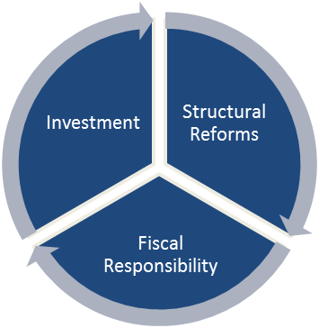
The 2015 Annual Growth Survey (AGS) was published by the new European Commission on 28 November 2014 under title of A new momentum for EU jobs, growth and investment. It sets out a challenging agenda of both economic and social policy development backed by an estimated €315 billion three-year Investment Plan. Its three core policy pillars are: a boost to investment, a renewed commitment to structural reforms and the pursuit of fiscal responsibility.

The structural reform pillar has the most immediate relevance to the development of disability policies in the Member States, with future potential resting on the investment pillar. However, urgent attention is also needed to the impact of fiscal consolidation and austerity on the welfare of disabled people in European countries.

The structural reform pillar emphasises the need for Member States to address high unemployment levels directly, to make labour markets ‘more dynamic’ and to deliver adequate social protection measures with efficient public administration. The Investment Plan rests principally on financial leverage instruments arising from the new European Fund for Strategic Investments (EFSI), in partnership with the European Investment Bank (EIB), but also includes a revised pipeline and technical assistance to identify credible projects and removal barriers to potential investment sectors and product markets. From a disability perspective, no project should be considered ‘credible’ if it is exclusionary or inaccessible for disabled people.

As well as social intervention projects targeting employment, the new Fund will support investments in infrastructures, including significant areas relevant to the social inclusion of disabled people – such as broadband, transport and education. For example, the kinds of ‘typical projects’ already identified by the joint Commission-EIB Task Force include the construction and renovation of public buildings, transport links and upgrading school facilities. There is an opportunity here also to increase accessibility for disabled people in these major infrastructures.
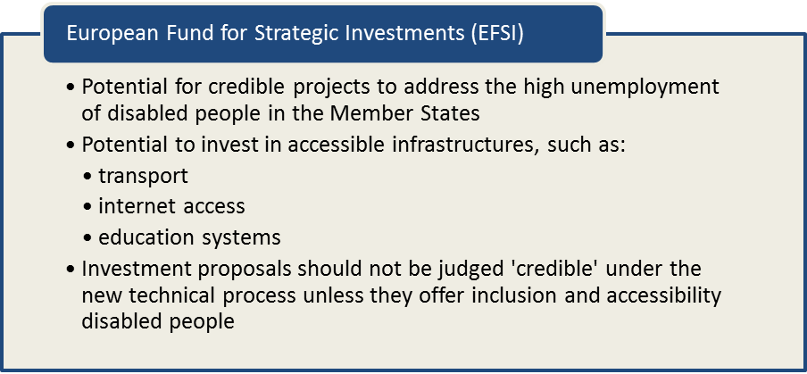

Publication of the AGS was accompanied by the 2015 Draft Joint Employment Report and the second edition of the scoreboard on employment and social indicators. These indicate that while overall economic activity rates have remained high so has unemployment, even though this has begun to decrease variably across the Member States. Among the key concerns, long-term unemployment is still rising, the proportion of young people not in employment, education or training remains high, there are significant labour force skills gaps, and the risk of household poverty and social exclusion has risen, notably for working age adults and children. As the ANED reports show, these concerns are exemplified for disabled people, who remain over-represented in unemployment, low educational attainment and household poverty risk.
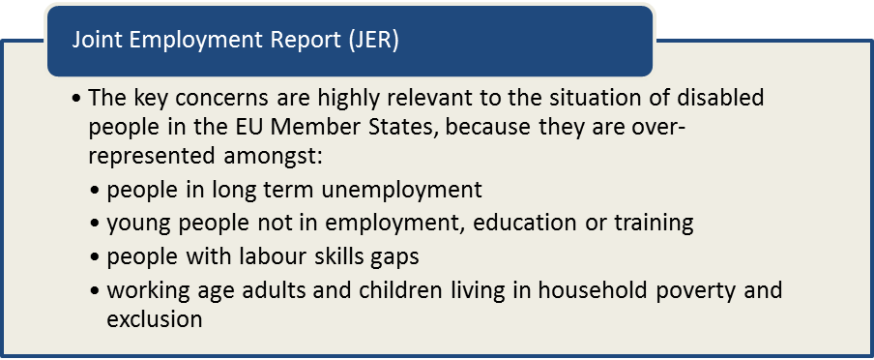

The following sections show the picture at the EU level, followed by reference to policy issues highlighted in the country reports accompanying this summary.

Assessment of the situation of disabled people with respect to the Europe 2020 headline targets

Strategic targets

The Europe 2020 strategy is based on five target areas relevant to achieving smart, sustainable and inclusive growth. These are expressed in ten headline indicators, supported by a scoreboard. Amongst the target areas, three are highly relevant to the full participation and equality of disabled people and to the concerns expressed in the Joint Employment Report for 2015 - employment, education and fighting poverty and social exclusion. The relevant targets and indicators for the general population in these areas are summarised below and were translated into national targets during the previous 2014 semester.

Table 1: Europe 2020 targets for the general population
 | Europe 2020 targets | Relevant Scoreboard indicators
Employment | 75% of the 20-64 year-olds to be employed | Employment rate - age group 20-64  - % of population aged 20-64  - Male  - Female
Education | Reducing the rates of early school leaving below 10% | Early leavers from education and training  - % of population aged 18-24  - Male  - Female
Education | At least 40% of 30-34–year-olds completing third level education | Tertiary educational attainment  - % of population aged 30-34  - Male  - Female
Fighting poverty and social exclusion | At least 20 million fewer people in or at risk of poverty and social exclusion | People at risk of poverty or social exclusion  - People living in households with very low work intensity  - People at risk of poverty after social transfers  - People severely materially deprived

Performance against these targets can be assessed from a disability perspective by disaggregating parallel measures for women and men with impairments/disabilities from EU statistical data. Whilst this methodology presents sample variations between Member States and some limitations, which are addressed in the country reports, clear patterns are evident at the European level.

Some Member States have also begun to develop their own disability equality data indicators across a range of measures to support national disability strategies and implementation the United Nations Convention on the Rights of Person with Disabilities (CRPD). However, few Member States have yet articulated any disability-specific targets against the EU2020 headlines. As shown in the following sections, the identification of such disability-related targets in the areas of employment, education and poverty reduction would be of considerable relevance to achieving the overall Europe 2020 targets for the population as a whole and should be encouraged in the preparation of the National Reform Programme packages.

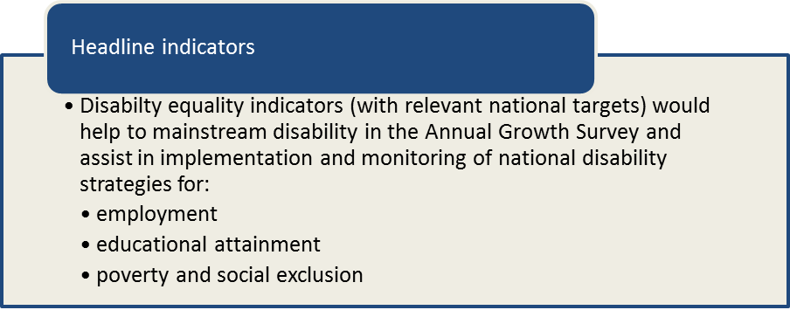

Unless specified, the summary statistics presented in the ANED country reports are derived from independent secondary analysis of 2012 EU-SILC micro data. The EU-SILC sample includes people living in private households and does not include people living in institutions (thus it excludes a small but important and socially excluded group of disabled people). The proxy used to identify people with impairments is whether ‘for at least the past 6 months’ the respondent reports that they have been ‘limited because of a health problem in activities people usually do’. Responses to this question vary considerably between countries and national data sources are thus cited in the country reports for comparison, where available.

Overall, at the EU level, 17.5%% of the EU population identify as limited to some extent and 8.6% as severely limited (26.1% overall). This represents a very significant proportion of EU citizens. The prevalence of activity limitation increases similarly for younger men and women but after the age of 40 women outweigh men (interestingly, this contrasts with administrative data on disability benefits, which shows in most Member States more men than women receive disability benefits).

Age profile is highly significant with 54% of people aged 65 and over identifying some form of limiting ‘health problem’ compared to 18.1% of those aged 16-64. Children under the age of 16 are not identified on this measure in the survey methodology and so it is not possible to estimate disability-related outcomes for children using the EU-SILC dataset. The following figure summarises these patterns for the EU average and is then compared per Member State in the country reports.

Table 2: Self-reported ‘activity limitations’ as a proxy for impairment/disability (EU-SILC 2012)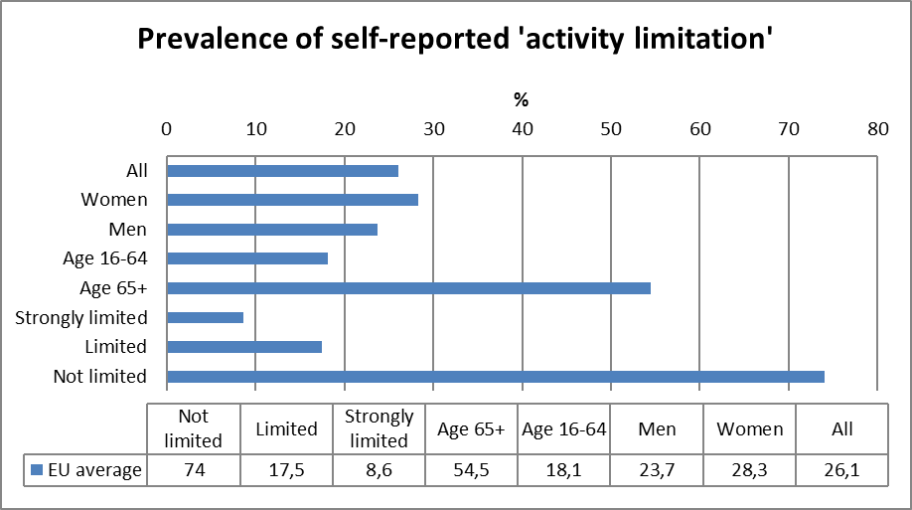
Source: EUSILC UDB 2012 – version 2 of August 2014

Employment data

New insights have been gained in 2014 with the opportunity to compare initial findings from the Eurostat 2011 ad hoc module on employment of disabled people against the indicators developed using EU-SILC. As a basis for annualised input to the European Semester SILC data still provides the best option as there is no standard disability identification in the quarterly LFS (which would otherwise provide a useful reference point). There is little difference in estimating employment rate for people reporting limitations in everyday life but the LFS also asks whether this includes limitations in working (for this group of people employment rates would be considerably lower in the LFS than suggested by SILC).

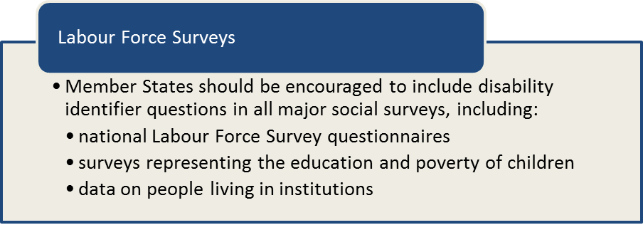

Table 3: comparison of data from EU-SILC (2012) and the LFS ad hoc disability module (2011)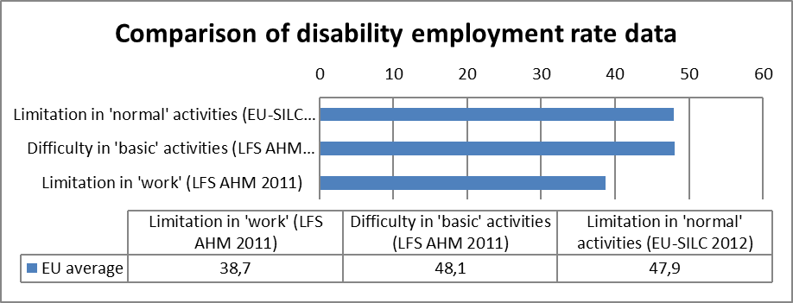
Source: EUSILC UDB 2012 – version 2 of August 2014, and Eurostat LFS AHM 2011

Overall, at the EU level, the LFS ad hoc module indicates a slightly higher estimate of disabled people’s employment than EU-SILC. As noted in the ANED 2014 report on statistical indicators, in terms of employment rates, ‘both surveys produce similar results except for Austria, Denmark, Finland, Ireland and Slovenia where the difference is higher than 5 percentage points’. These differences may stem from sampling differences and from seasonal employment factors (e.g. in Austria and Slovenia). Despite these national differences, the overall correlation between the two surveys is very good (R²=0.85) and there is no significant reason not to look to EU-SILC for an indicative picture at the EU level. The individual country reports highlight where national data may provide an alternative or more reliable national perspective.

Without doubt there is a significant employment rate gap between disabled and non-disabled people and this has been estimated at 24 percentage points (with an employment rate of 47.9% for disabled people and 71.5% for non-disabled people). The overall EU employment rate is thus 67%. In crude terms, the difference that disability makes to achievement of the headline EU target is currently between 4 and 5 percentage points. It is therefore important to underline that it will be difficult or impossible to achieve the overall target of 75% employment rate across the EU without increasing the employment rate of disabled people. This is an important policy challenge in terms of national targets too and needs to be acknowledged in National Reform Programmes.

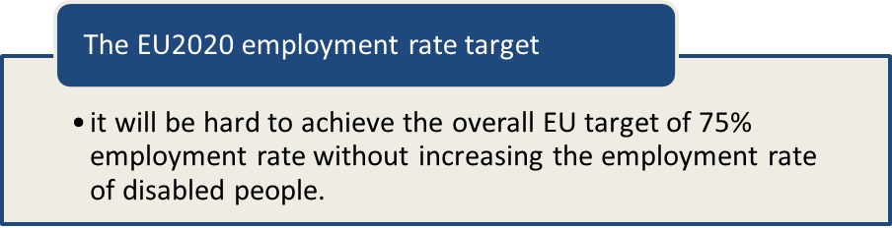

The following table shows the typical pattern of distribution, using the EU28 averages for 2012, in which severity of impairment and gender also interact to produce hierarchies of inclusion in employment. On the one hand, there is a clear tendency for employment rate to decline with severity of impairment (with people declaring a severe level of limitation in basic activities only half as likely to be employed as those declaring a limitation only to some extent). On the other hand there is a distinct gendered pattern in the disability employment gap but in which disability acts as a more determinant factor than gender (both disabled women and men are less likely to be employed than their non-disabled counterparts but men are more likely to be employed than women in the each group).
Table 4: Impairment and gender factors in employment rate data, aged 20-64 (2012)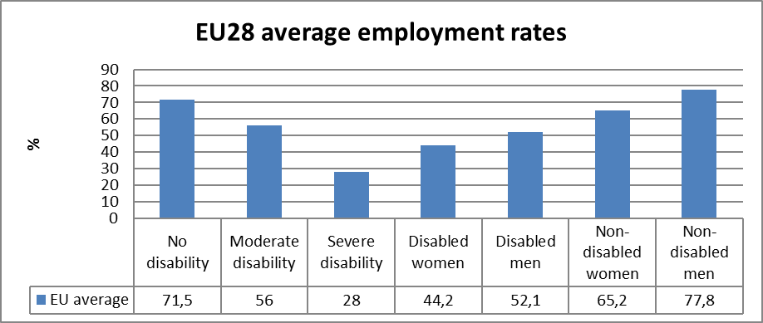
Source: EUSILC UDB 2012 – version 2 of August 2014, and Eurostat LFS AHM 2011

It is worth noting that in a few countries these general patterns are disrupted, notably in the relative significance of gender equalities arising from the national labour markets and welfare regimes. To some extent, disability and gender equality gaps are associated, with narrower equality gaps in social democratic welfare states and wider inequalities in liberal market economies. Most significantly, as shown in previous years, countries with similar employment rates for non-disabled people present large differences for disabled people. This underlines the fact that economic and social policies do make a difference to disability equality outcomes and that that there is potential to raise the employment rate of disabled people. Disability is by no means a ‘natural’ reason to be excluded from employment for all.

In general terms, disability inequalities in employment rates can be tracked throughout working age life but they are wider in mid-career than amongst older workers. However, the country reports illustrate much diversity in the extent to which disabled people’s employment lags behind that of non-disabled people in different working age groups. In some countries, the drop off in employment amongst older workers can be more closely identified with disability status than in others.
Table 5: EU employment rate data, by age group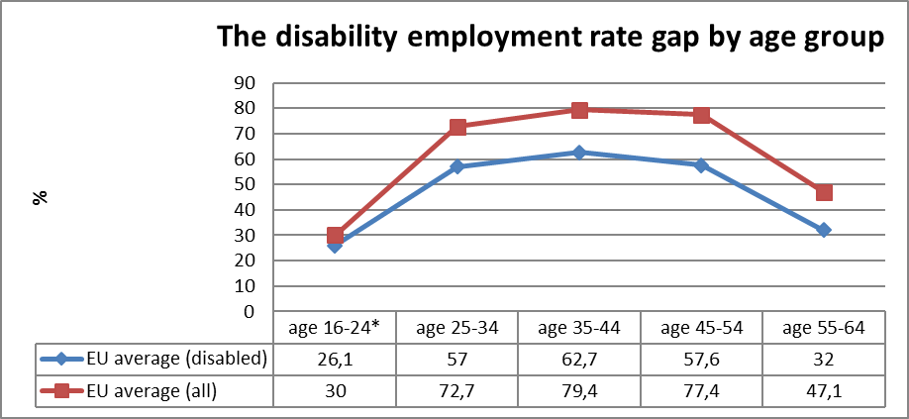
Source: EUSILC UDB 2012 – version 2 of August 2014 (and preceding UDBs)

Unemployment

National administrative rules and definitions on ‘unemployment’ can affect the way in which people with disabilities are categorised in different countries. However, at the EU level, disabled people are more likely to be unemployment than the general population while the influence of gender inequality is small (both disabled and non-disabled women are only slightly less likely to be recorded as unemployed than men in the same category). In 2012 the unemployment rate for disabled people in the EU28, as indicated by SILC, was 18.1% compared to 11.2% for non-disabled people. Again, it is relevant to note the difference that disability makes to the total EU unemployment figure, which is 1 percentage point (the unemployment rate for the total population is 12.2%).

Table 6: Disability and gender in unemployment for EU28, aged 20-64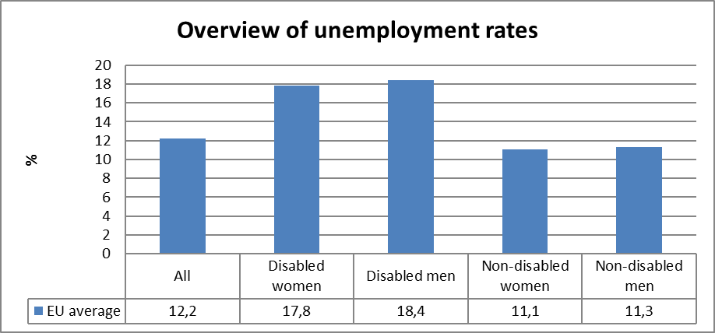
Source: EUSILC UDB 2012 – version 2 of August 2014

Mirroring the evolution of employment rates across the working life course, the unemployment gap is evident for all age groups but widens for older workers.

Table 7: Disability and unemployment rates, by age group
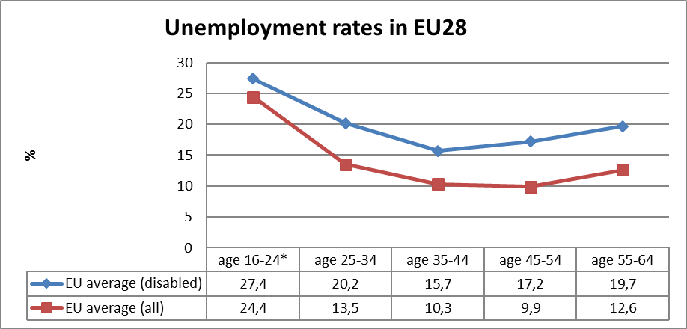
Source: EUSILC UDB 2012 – version 2 of August 2014
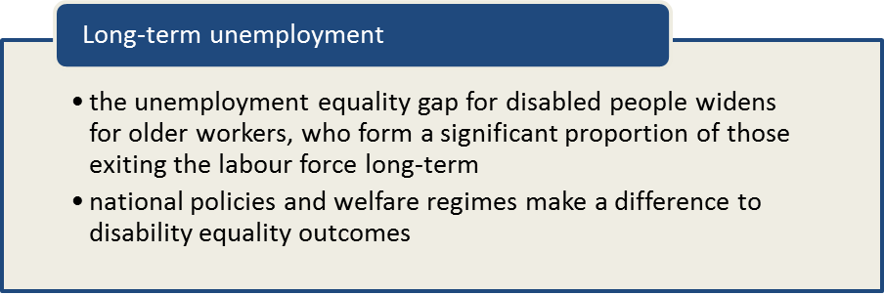

Economic activity

Compared to unemployment, economic activity is a more significant indicator in the disability context. Across the EU 58.5% of people who report a limiting ‘health problem’ are active in the labour market, compared to 80.5% of those who do not – an equality gap of 22 percentage points at the European level. The difference that disability makes to the overall EU activity rate is thus more than 5 percentage points (as the total population activity rate is 76.3%). This is again a significant policy challenge and helps to explain why various Member States have chosen to focus economic activation policies towards disabled people outside the labour market.

The participation rate of disabled people (using the EU-SILC proxy measure) has risen from 56.7% in 2011, and rose faster than the economic activation of non-disabled people in the same period. This may be due to new combinations of policies targeting the activation of people claiming disability-related out-of-work benefits and merits further investigation at the national level. As discussed later, it is important to consider the potential impact of such policies on poverty and social exclusion.

As noted in the ANED 2014 draft statistical report: The activity rate appears particularly low in Malta (27.1%), Hungary (38.3%) and Croatia (40.7%) with apparently high activity rates in Finland (65.5%), Sweden (69.4%) and Germany (71.5%). As with employment, countries with similar activity rates for non-disabled people present big differences in the activity rate of disabled people, suggesting the potential for activation policies to make a difference. However, it is not evident from the country reports that Member States making the strongest efforts to target disabled people are amongst those with the highest activation rates. Rather, activation appears to be more closely associated with strong social protection measures and narrow equality gaps in society overall (although it is difficult to attribute causal explanations in the comparison of highly complex policy systems).
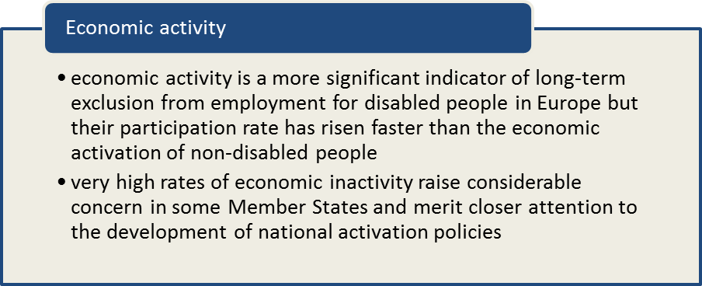

Table 8: Economic activity rates for disabled women and men, aged 20-64
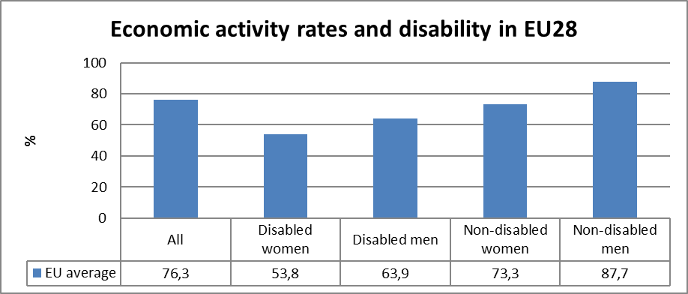
Source: EUSILC UDB 2012 – version 2 of August 2014

These activity rates can also be tracked across the working life course, and show a similar pattern to the evolution of employment rates.

Table 9: Activity rate data, by age group
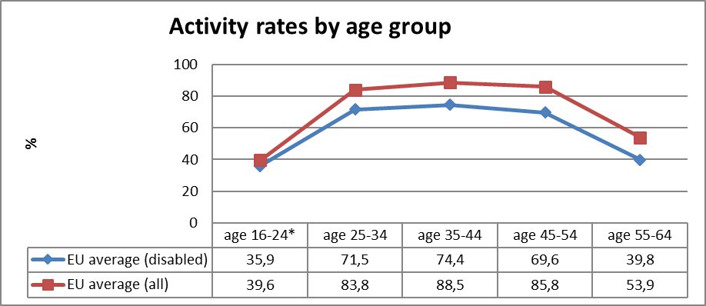
Source: EUSILC UDB 2012 – version 2 of August 2014

Education data

EU statistical comparisons are more limited concerning the education of young women and men with disabilities in the EU2020 target age groups. Data is available from EU-SILC (annually) as well as the Eurostat Labour Force Survey ad-hoc disability module (for 2011), but with low reliability for several countries on the key measures. Using a wider age range can improve reliability but estimations by gender remain indicative. EU trends are evident but national survey and administrative data cited in the country reports may offer more reliable alternatives, where available. The European Agency for Development of Special Needs Education may also have a role to play in facilitating data sharing and indicators.

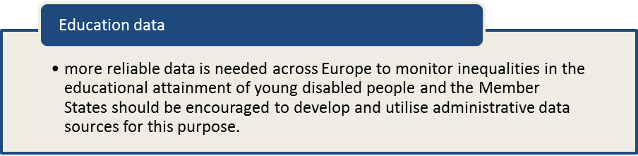

Early school leavers

The Europe 2020 headline target refers to reducing the proportion of early leavers from education in the age range 18-24. Due to the heavily weighted age profile of the disabled population towards older age there are relatively fewer young disabled people. This is reflected also in major social surveys, including EU-SILC where there were some 2,693 young people in this age group identified with a limiting ‘health problem’ (the indicator proxy for impairment/disability). This sample provides a reasonable indication of patterns at the EU level but becomes unreliable at the national level for several countries (and falling below the minimum indicative sample size in a few). These limitations are highlighted in the country reports with reference to actual numbers as well as indicative averages.

The new Eurostat disability database uses data from the 2011 LFS ad hoc module to indicate on this measure but this also produces sample sizes too small to make very reliable estimates at national level, particularly if disaggregated for gender effects. It is evident that there are some discrepancies between the two datasets (and notably in some countries like Greece, Malta, Luxembourg and the UK). This is likely to reflect both sampling differences and the structure of the relevant variable, in terms of educational level achieved (including national qualification framework definitions).

Eurostat defines ‘Early leavers from education and training’ with reference to highest ISCED qualification level. However, it is not possible to distinguish borderline level ‘3c short’ courses in the EU-SILC UDB version of the micro-data and so the SILC based indicators may also underestimate the proportion of early school leavers.

At the European level, it is clear however that young disabled people are overrepresented amongst early leavers from education and this remains true when repeating the analysis for a larger 18-29 age group. Indeed, young disabled people are twice as likely to be early leavers overall.

Table 10: Early school leavers aged 18-24 (2012, indicative)
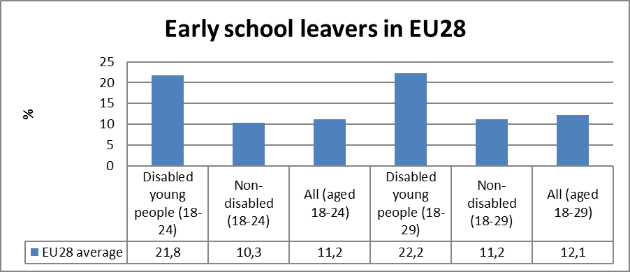

Tertiary education

A similar problem is presented for the Europe 2020 headline target on attainment of tertiary education, since the target indicator group are those in the narrow age band 30-34. Again there is a significant difficulty in reliably indicating the situation for young disabled adults in this age group given the age profile and sample size reflected in EU-SILC data, as well as the LFS ad hoc module (there were some 2,801 people identified with a limiting ‘health problem’ in the 2012 SILC data across all 28 Member States). These limitations are highlighted and illustrated in each of the country reports with the addition of alternative data where available.

At the EU level, it is again possible to make some reasonable estimation of the general pattern and challenges (which can be verified by repeating the analysis for wider age group aged 30-39). Clearly disabled people at the beginning of their adult careers are less likely to have completed tertiary education and this remains true up to the age of 40, with a persistent equality gap of more than 10 percentage points.

Table 11: Completion of tertiary or equivalent education (indicative based on above sample)
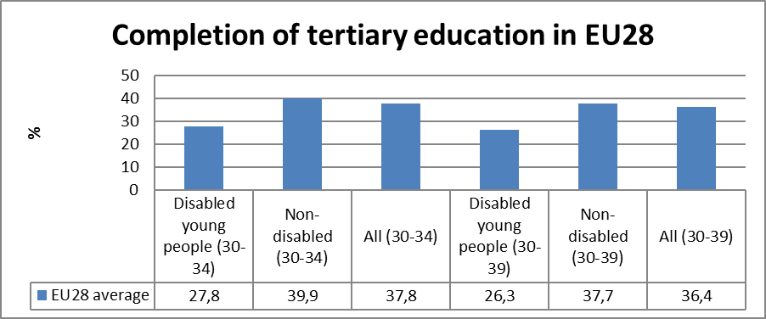
Source: EUSILC UDB 2012 – version 2 of August 2014

Poverty and social exclusion data

EU SILC data provides indicators of the key risks for disabled people. In addition to household risks of low work intensity, there are risks of low income (after social transfers), and material deprivation. These three measures are combined in the overall estimate of risk. The risks for older people do not include work intensity (Eurostat refers to the age group 0-59 for this measure). As mentioned in the introduction, the survey does not distinguish ‘activity limitation’ (the proxy for impairment/disability) for children under the age of 16 and thus it is not possible to elaborate on the specific disability risks of child poverty using this data. However, many of the country reports make reference to alternative national data sources, some of which explicitly relate to disability as a factor in household poverty and social exclusion, and including children in some cases.

As the following tables show, at the EU level, disabled people and their families face significantly greater risks of poverty and social exclusion on all the key measures used in developing the Europe 2020 Scorecard indicators. In particular the risk of household low work intensity for people of working age is considerable – 24% for disabled people compared to just 8.2% for non-disabled people (a gap of 15.8 percentage points). Whilst the risks and gaps for low income and material deprivation are lower the general pattern is consistent on all three indicators.

Table 12: People living in household poverty and exclusion by key risk (2012, aged 16-59)
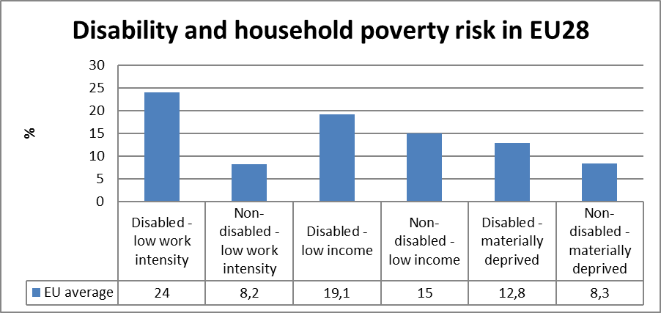
Source: EUSILC UDB 2012 – version 2 of August 2014

This emphasis on working age poverty risk is striking when considered in the context of risk across age generations. It is also a challenge identified in the 2015 Joint Employment Report (discussed below). The important point is that the disability poverty challenge is significant and that it is strongly connected with low work intensity that affects whole households as well as individuals.

Looking at the overall risk of poverty and social exclusion (as calculated by combining the three component risk factors and applying them to all those aged 16 and over) the EU pattern is evident. This shows clearly that overall risk, for households, increases with severity of reported impairment, and that impairment factors and gender factors interact. However, gender inequalities may be under-represented when the distribution of resources within the household is not shown.
Table 13: People living in household poverty and exclusion by gender and severity (aged 16+)
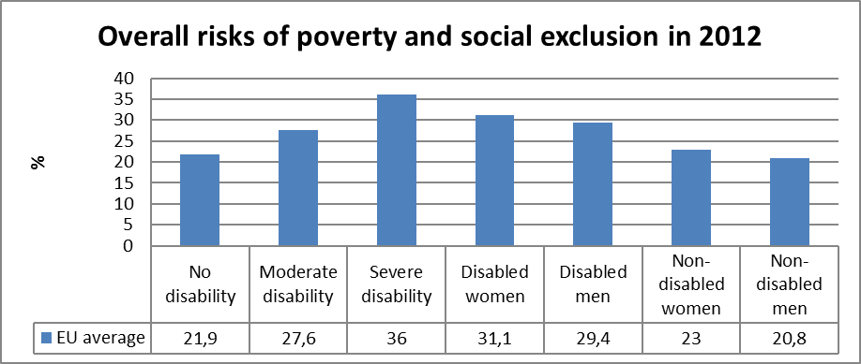
Source: EUSILC UDB 2012 – version 2 of August 2014

Returning to the theme of population age structure, it is important to underline that overall risk of poverty and social exclusion across Europe is greater for adults of traditional working age (16-64) than it is for older people (aged 65 and over). This is also true for disabled people and may be in large part due to the protective influence of contributory old age pensions accumulated through periods of economic stability and growth. In both age groups disabled people are more likely to live in households at risk but both the risk and the equality gap are greater for those of working age (where low work intensity contributes greatly to their risk).

Overall, at the European level, 30.4% of disabled people aged 16 and over live in households at risk of poverty or social exclusion compared to 21.9% of non-disabled people in the same age group. Thus the difference that disability makes to the EU headline indicator is 2.2 percentage points (the overall average risk in the EU being 24.1%).

Table 14: Overall risk of household poverty by main age group (all, aged 16+)
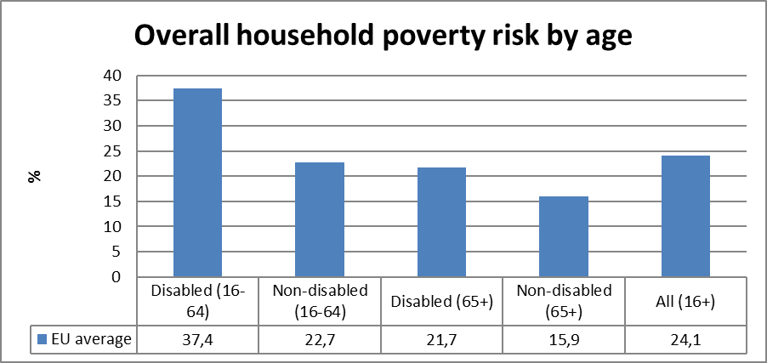
Source: EUSILC UDB 2012 – version 2 of August 2014

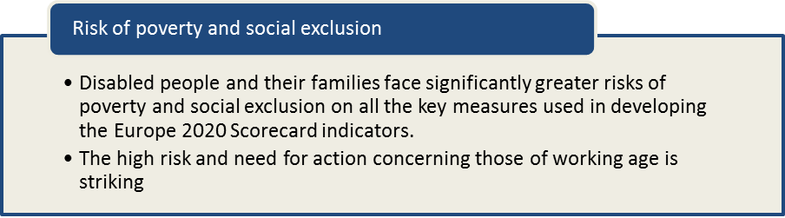

Assessment of policies in place to meet the relevant headline targets

As identified in 2013, there has been a continuation of characteristically neo-liberal policy responses to the crisis in several countries, notably in reducing eligibility for state welfare support and decentralising implementation responsibility, either to local budgets or to increased expectations of individual responsibility in the market. These policy shifts underline the need for closer attention to monitoring and evaluation of the effectiveness and the equity of outcomes in different regions and for different client groups, including for younger disabled adults and for older workers, including for those with more severe or fluctuating impairments and health conditions (significant the accentuated risks of precarity and social exclusion faced by many people with mental health conditions).

Following the preparation of the ANED preliminary situation reports, and publication of the 2015 AGS, the Member States’ will elaborate their National Reform Programme packages (now in preparation for submission in Spring 2015). These 2015 submissions will provide a basis for revision of both the country reports and the elaboration of trends and issues in this flash synthesis overview. The preliminary ANED briefings, prepared in November 2014, highlight numerous examples of policy development that would be relevant for inclusion in these packages, under the following three headings.

Employment policy issues

The following developments and challenges were highlighted in the preliminary country reports.

COUNTRY
Austria | An intrinsic problem in the Austrian context is that positive measures for the employment of disabled people are not widely discussed. Companies do not widely fulfil the compulsory employment quota (Beschäftigungspflicht) and often prefer to pay the compensation levy (Ausgleichstaxe).
Belgium | There are problems at the recruitment stage, including employer stereotypes and insufficient opportunity in the open labour market. The relatively small difference between the integration allowance and ‘normal’ income creates a benefit trap, while disabled people who lose their jobs no longer receive a replacement income (creating an employment disincentive).
Bulgaria | Disability employment promotion programmes encourage and support employers to hire disabled people but there is a lack of support and access to realise opportunities (e.g. transport, technical aids, personal assistance, accessible environments). Many disabled people are hired in special enterprises and protected workshops, which enjoy tax relief or rebates. However, the quality of these jobs is often low and the salaries close to the minimum wage. Several schemes under the Human Resource Development Operational Programme (co-financed by the European Social Fund) target disabled people but there is not yet evaluation of long-term employment outcomes.
Croatia | The new Law on Vocational Rehabilitation and Employment of Persons with disabilities came into force in 2014, with non-discrimination requirements and a new private sector employment quota. The existing public sector disability employment quota will also be increased from 1:19 employees to 1:16. The employment service implemented a Package of measures targeting disabled people. The Fund for Professional Rehabilitation and Employment of Persons with Disabilities continues also to provide some incentives and grant payments.
Cyprus | There are a number of legal barriers that undermine attempts to enhance the employability of disabled people. The ‘reasonable measures’ caveat in the Individuals with Disability Law (Ν. 127(Ι)/2000) allows employers to evade legal obligations. For example, in relation to public sector obligations, the caveat allows consideration of ‘the financial conditions and other obligations of the state’.
Czech Republic | The ‘Social Reformation’ adopted in 2011 has resulted in changes in public administration. Labour authorities are now responsible for a wider range of implementation, which has resulted in significant disruption. The withdrawn employment subsidy for people ‘disadvantaged in health’ was reinstated in 2014 and sheltered workshops abolished. Vocational rehabilitation support is not fulfilling its potential for disabled people in the open labour market and the promised ‘complex rehabilitation’ initiative has not been implemented.
Denmark | For some decades, the government has been pursuing a policy aiming to employ more disabled people and the number of flexi jobs has increased significantly since 2000. The policy has also aimed to inform enterprises about the support schemes available, and to get them to function more smoothly. The impact of these efforts has been that more companies and employees are aware of the schemes, and the attitude to hire people with disabilities has become more open but there is no corresponding development in the overall employment rate (suggesting displacement to targeted schemes rather than additionality).
Estonia | One of the main strategies for bringing the disabled person into the labour market is the current Work Capacity Reform and the government are consulting with disabled people on this. The main concerns are related to the allocation of funding to the re-evaluation of people’s capacity to work rather than to supportive employment services. In 2013 labour market services were provided to only half of unemployed disabled people and there were very few targeted measures.
Finland | Severely disabled young adults need much more individual guidance on applying for work and marketing their skills to employers. Few find open labour market positions and the attitudes of employers present barriers but more customised work and employment relationships are also needed. Quality of training, flexibility, wage subsidies and work trials appear to be positive factors but there is little outcome in terms of permanent paid work. Job coaching is an increasing area of workplace practice.
France
Germany | The supported employment system is intended to secure disabled people a reasonable job in the open labour market subject to social insurance contributions. It includes training in a private company or business, and if necessary personal support in the work place to sustain employment (primarily job coaching) but may become less needed with the expansion of personal coaching in transition from school to the labour market.
Greece | The Action Plan for the Creation of New Job Placements and Support for Unemployment 2013-2015 prepared by the Ministry of Work, Social Security and Welfare, captures 12 actions in total, funded and implemented through structural funds 2007-2013 and ESIF 2014-2020. Half of these actions target young people, specifically aged 15-24, 25-29 and up to 35, whilst two actions are more specifically linked with community work and social economy initiatives. Specific programs for disability or other ‘vulnerable social groups’ are not included in this Action Plan. What is missing is a national policy framework that will ensure that such support is in place and will provide guidelines and targets for increasing participation of disabled people in mainstream active labour policies.
Hungary | Employment policy has focused on two general measures, cutting social benefits to motivate (disabled) persons to find work and financing low paid public worker positions. This has diverted resources from active labour market measures and there are no targeted labour market services for disabled people. There are some employment tax incentives and a quota scheme. The number of people holding a Rehabilitation Card entitling the employer to a tax deduction has risen considerably.
Ireland | The Department for Jobs, Enterprise and Innovation committed to publishing a comprehensive employment strategy for people with disabilities and ran a programme of activities to promote employability of excluded groups. However, this has not been published. In 2013 a new Further Education and Training Authority was established under the name SOLAS. The 2014 Further Education and Training Services Plan includes a specialist training programme for disabled people in five locations. The complete segregation of this training may discourage inclusion.
Italy
Latvia | In addition to Guidelines on the Implementation of the UN Convention on the Rights of Persons with Disabilities 2014-2020, new Guidelines on Inclusive Employment 2014-2020 were also developed, as well as determination of a minimum level of income. From 2014 the State Employment Service implemented new youth guarantee support measures for unemployed young.
Lithuania | The 2014 NRP included a range of relevant policy proposals but these were not elaborated in relation to disability. The Law on Support for Employment was amended with reduced options for disabled people.
Luxembourg | The national action plan to implement the CRPD includes legislative proposals to promote employment but most are declarations of principle or intent. The new program of the Government (2013) states a commitment to improve support and promote labour market inclusion (insertion dans emploi). The capacity of ‘sheltered workshops’ will be increased and this measure is also identified in the NRP (along with investment in job-coaching projects, awareness raising campaigns etc).
Malta | Many disabled people have been disadvantaged in education and there is also a lack of willingness on the part of employers. A benefits trap is evident in the earnings related entitlement to disability pension. Many disabled people prefer to engage in part-time work or low paid jobs to retain the security of the pension.
Netherlands | An extensive reform of sheltered employment and the benefit scheme was agreed, notably for those now eligible for the early onset disability benefit Wajong. Entry into sheltered employment will cease from 2015. All new applicants for the Wajong benefit and all existing recipients will be assessed. Only those who are deemed not to be able to work at all will be entitled to receive the benefit. All others will be entitled to support in finding work by municipalities. If they do not succeed in finding work they will be eligible for unemployment provisions, provided by municipalities.
Poland
Portugal | Comparing the budget spent and the numbers of disabled beneficiaries of vocational training and employment measures from 2012-2014 it is clear that public investment in this area is decreasing. While total public spending in vocational training and employment measures for the general population more than doubled during this period, it decreased by over 50% for the target group ‘persons with disabilities’.
Romania | The key objective of the Draft National Strategy on Disability related to employment is to provide equal access to employment for disabled people in the open market. This includes improving mechanisms of evaluating and stimulating working capacity, ensuring supported employment and developing dialogue/social partnership between stakeholders.
Slovakia | The most relevant policy is currently the National Disability Program, which sets a strategic objective in the area of employment, especially by increasing the accessibility and availability of public employment services and counselling, as well as attention to the employment in an open labour market. However, no indicators to measure progress were set. There is relatively low expenditure on active labour market policies and this has declined over the past two years (including allowances to stimulate sheltered workshops and self-employment).
Slovenia | The new Rules on technical aids and adapting vehicles specify the right to technical aid for people with sensory and physical impairments. This law may help increase accessibility in the area of employment and social inclusion of people in these groups and improve adaptation of the working environment from October 2014.
Spain | Although there are many measures to promote employment in the Disability Action Plan 2014-2020, there is a lack of strategy and specific proposals to evaluate the outcomes of the proposed measures. Specific indicators are needed to compare outcomes over time in terms of investment, cost-efficiency, efficacy, results as well as the satisfaction of disabled workers themselves.
Sweden | The labour market situation for many people with disabilities is still critical. Efforts to date have not been sufficient. The maximum level of contributions qualifying payroll for employment with wage support are relatively low, and a simplified structure for salary support is needed.
United Kingdom | The Action Plan accompanying the revised national disability strategy, and linked to CRPD implementation, includes 41 policy initiatives on employment. The key action was to develop a new employment strategy for disabled people and people with health conditions and initial proposals were published in December 2013. There was an emphasis on employer knowledge and attitudes, with priorities for supporting young disabled people in transition and people with mental health conditions. The strategy envisaged a new gateway into employment services with a focus on more personalised forms of employment support. It was accompanied by a one-off additional budget allocation of £350m for 2015/16 (allocation to be finalised).

Education policy issues

COUNTRY
Austria | There seems to be little awareness of young disabled people in policies, programmes and data with regard to early school leaving. Similarly, there appear to be no distinct policies or programmes to increase the number of disabled people in tertiary education. The targets and measures described in the National Action Plan on Disability are vague and no information is available on implementation progress. An important first step would be to include disability as a category in data collection on education in Austria.
Belgium | The number of disabled students in tertiary education is very low. High schools and universities are not generally accessible and their environment is highly competitive. There have been recent budget cuts for higher education. In Flanders, however, there is some evidence of improvement in universities and have reactivation of the Support Center for Inclusive Higher Education (SIHO).
Bulgaria | The Bulgarian education system is still characterised by segregated provision and there is a lack of independent research, monitoring or evaluation. There appears to be some progress towards inclusion of disabled children in mainstream schools but data is also scarce and difficult to access. One of the key barriers to employment for disabled people is low education and skills levels.
Croatia | The government adopted a new Strategy on education, science and technology. The chapter on Higher Education includes an objective to provide minimum standards of accessibility and adjustment, based on eight measures (funding, admissions, teaching, assistive technology and assistants, institutional services and professional bodies, spatial accessibility and universal design, transportation, and data collection).
Cyprus | Early intervention should be applied through universal screening assessments to identify students at risk. New accountability regimes and effectiveness indicators are needed. Particular emphasis needs to be given to the meaningful participation and achievement of students designated as having SEN/D.
Czech Republic | Statistical evidence from some universities indicates that the number of disabled students is steadily increasing. However, the legal right to support in tertiary education is not fully established in the 1998 Higher Education Act. The Czech Government recently introduced an Amendment to the Act but this also does not spell out fully rights and obligations for the tertiary education sector.
Denmark | The situation may change as a result of two reforms in the primary education field (the introduction of full-day provision and increasing integration of pupils with special needs in mainstream classes). Over the past decade there has been a steady increase in the number of children referred into special needs classes, and in the proportion of the education budget spent on special needs education. The reform aims to reverse this trend. From 2014, a large number of school children who previously attended special needs classes have been integrated into regular classes. There are no evaluations of this reform yet, although both positive and negative experiences have been discussed in the media.
Estonia | Special attention should be paid to reducing withdrawal from the labour market due to long-term illness, incapacity for work, disability or caring obligations by providing targeted welfare and support measures. The Chamber of Disabled People has developed a website on the Work Capacity Reform that outlined concerns prior to passage of the Law on Benefits of Working Capacity in December 2015. It will be important to monitor the impact on disabled people in terms of poverty and social exclusion.
Finland | The biggest challenge is educational equality. The dual system of education (mainstream and special education in basic and vocational education) creates segregation, although inclusive learning environments have also developed.
France
Germany | As schools are under the domain of the 16 federal states, and policies greatly vary, it is difficult to get a clear picture but school leaving without the basic qualification of Hauptschulabschluss remains a major problem for the special school system and for disabled pupils.  The quantitative reduction targets make no reference to disability in early leaving or progression to tertiary education, although education is considered by Federal Ministry for Economic Affairs and Energy as ‘key to participation, integration and equal opportunities – core elements of the social market economy’.
Greece | The Ministry of Education’s ‘New School’ strategic framework to address early school leaving and employment skills includes disability measures and a new policy framework, based on principles of inclusion and equality, is expected to replace the existing special education legislation. A committee has been established to harmonise national legislation with the CRPD, the production of accessible material and the promotion of e-accessibility (including certification for sign language and Braille and annual evaluations of inclusive education interventions).  It is still at the discretion of Universities to determine access and support for disabled students. By contrast, accessibility in private education and lifelong learning units was addressed by a circular of the Ministry of Education in April 2013, which included accessibility requirements among the conditions for renewing licenses for establishments with a capacity of more than 75 students per teaching hour.
Hungary | The elaboration of governmental strategy to reduce the number of early school leavers was instigated by a governmental decree in the Spring of 2013 with a deadline of December 2013 but has not yet been accepted and published.  In higher education the most significant change has been the reduction in public contribution to certain faculties, such as law, social and economic studies. The new government announced the first draft of a higher education reform program in October 2014. The introduction of a mentor program for disadvantaged persons is the only measure in relation to disabled people.  The 2014 NRP contained an objective to promote the academic success of pupils with special needs and the service system for counselling on special education, early development and care, expert and rehabilitation activity has been completely restructured.
Ireland | Key portions of the Education for Persons with Special Educational Needs Act (2004), such as Integrated Education Plans, remain unfunded - limiting support for disabled pupils to remain in school and continue into third level institutions.  In February 2014, The Hub, a new initiative for young adults with Autism or complex needs was launched in Drogheda. The initiative will provide community and activity support and is a partnership project. Although promising, it is only a local service and will have limited impact on the national shortage of placements for school leavers with intellectual impairments.
Italy
Latvia | One of the action lines of the Guidelines for Education Development 2004-2020 is ‘inclusion of learners with special needs into the education system and introduction of the principle of inclusive education’.
Lithuania | Along with the preparation of an action plan for the development of vocational training 2014-2016, the Law on Vocational Training was amended to include the reorganization of vocational training institution networks relevant to regional industries, training vocational teachers, arranging internships in workplaces, and adapting a new qualifications framework.
Luxembourg | Approximately 1% of the school population is supported throughout the day in special education (éducation différenciée), which is low compared to the European average. Each school offers children with special educational needs an individualised progression plan. All teachers must possess basic knowledge in special needs pedagogy and this requirement is considered in initial teacher training. As part of a future reorganisation of the course, teachers should familiarise themselves with the basics of special needs pedagogy and universal design.  A new government programme in 2013 aimed for inclusion based on implementation of the CRPD, although the preference of parents to educate their children in a special school will be respected. A restructuring of all services for children and youth with special needs will be conducted. Multi-professional teams will be established in post-primary education with guaranteed financial backing.
Malta | Disabled students who attend special schools do not feature in early leavers data as they continue until the age of 23 (and sometimes even longer). However, few disabled children attend special schools and the inclusive education policy introduced in 1994 has been largely successful in primary and secondary schools. This has not yet been translated into inclusion at higher levels of education. The majority of young disabled people have not progressed beyond secondary education.
Netherlands | Municipalities are concerned that it will be difficult to reduce early school leaving further due to a tighter assessment regime vocational training schools and introduction of language assessments. Vocational schools may initiate introductory classes for pupils with anticipated language skills or learning difficulty and refuse transfer to vocational education (students who begin introductory classes but are later refused entry in vocational education will not count as early school leavers). Municipalities fear an incentive for vocational schools to stream out disabled students seeking vocational training after finishing special secondary. These students will then face an extra hurdle to getting accepted in vocational education.
Poland
Portugal | The 2014 NRP does not contain directly relevant measures to early leaving but does refer to the National System of Early Intervention (SNIPI), which supports children up to 6 years old. The rate of coverage of pre-school education, the number of children receiving support, and the number of teachers involved has increased. Disability topics are needed in teacher and support staff training to support new legislation providing for the mainstreaming of disabled children in regular schools.  Universities are not subject to specific non-discrimination laws they may be covered by Article 6 of the Anti-Discrimination Law (Law 38/2004) and there is also a regulated quota for national applications to higher education reserved for students with physical and sensory impairments (2% of vacancies). Some universities have developed staff guidelines and established Disabled Students Support others offer no support.
Romania | The key objective of the new draft Strategy is to ensure equal access to education for disabled children and young people, including: legislation and mandatory access to education, choice of provision in the mainstream, accessibility, improved educational support measures, teacher training, career counselling etc.
Slovakia | The National Disability Program 2014-2020 includes a goal on education at all levels, including lifelong learning. One of the most significant measures is a new dual secondary education scheme (including practical training with employers). According to Act No. 245/2008 on Education (School Act) as amended (Article 95) and the proposal for an Act on Vocational Education and Training disabled pupils are not excluded from this dual system. However, indicator measures are need to monitor the impact on them.  In autumn 2013, the Advisory Board of the Minister of Education for Support of Students with Specific Needs was established to monitor study conditions in higher education. Data has also been disaggregated on students with specific needs in the Central Register of Students, which will facilitate planning of supportive measures. One of the main challenges is to raise awareness in University boards of the need to invest budgets and staffing in equal opportunities.
Slovenia | There are some positive trends in the area of education, such as more children with disabilities enter elementary, secondary and tertiary education. National data show that disabled people are generally included but remain in educational programmes for a long time (even up to the age of 26 years). Thus some may not appear in data for the ‘early leaver’ age group. Reliable statistics are missing but there is a slight increase of disabled students at tertiary level.
Spain | There is a lack of specific measures and a need to disaggregate disability data, not only in the number of students in each formative stage but regarding the results of their training and their transition through the education system, including in the analyses different variables (e.g. schooling years type of schooling, academic performance, hours of support received in the classroom, outside the classroom hours, etc.) to help identify cost-efficacy, efficiency and outcomes.
Sweden | The Swedish National Agency for Education should in their mission of open reporting and comparisons of schools also require schools to report on physical accessibility.
United Kingdom | The national disability action plan contains 8 initiatives under the heading of education.  In a major reform, from September 2014, Statements of Special Educational Need (SEN) and Learning Difficulties Assessments in England are replaced by Education, Health and Care Plans (EHCP) with the aim of a more holistic approach up to the age of 25. The main challenges are likely to be in co-ordination between agencies and staffing capacity for SEN co-ordinators.  Education Maintenance Allowance (EMA) was abolished in England as part of the post-2010 budget cuts (and devolved to college bursary funds) but has been maintained in Scotland, Wales and Northern Ireland. Equality Impact Assessments indicate only a small proportion of disabled claimants (4% in Northern Ireland, 5.3% in Wales) but point to the relative disadvantage for young disabled people, and the potential for ‘unintended discrimination’ in devolving responsibility to individual colleges.  In April 2014, cuts were announced to the level of the Disabled Students Allowance from 2015. Following concerns raised in consultations with students and universities the changes were postponed until the academic year 2016-17.

Poverty and social inclusion policy issues

COUNTRY
Austria | Policies tend to conflate disabled people into a much broader category, such that their risk is not particularly visible in policy debate. The non-effectiveness of measures to reduce this risk arises from the complex interaction of policies, notably the cumulative impact of educational exclusion for young disabled people.
Belgium | Many disabled people receive a disability allowance from the federal government but there is a long waiting time and the amount is too low amount to support independent living. In Flanders, there is new legislation providing a budget attached to the person (‘persoonsgebonden financiering). A further issue is that income replacement (provided by the regions) creates a barrier to employment. Its adjustment to the partner’s income penalises couples and prevents disabled people from meeting expenses in everyday life.
Bulgaria | The National Reform Programme 2014 describes success in deinstitutionalisation but there are insufficient income supports to enable choice in community living. A financial standard has been introduced where ‘money follows the client’ in residential care but not for community living for those who want to leave group homes. Preserving the disability assessment related to the impairment diagnosis without consideration for individual functional needs also remains a block to inclusion.
Croatia | The Strategy for Combating Poverty and Social Exclusion 2014-2020 has defined various vulnerable groups, including people with mental health conditions or severe physical impairments. These groups are highlighted due to the obstacles for labour market entry (including for family carers).  One of the goals of the National Youth Programme 2014-2017 is to improve support for young people at risk of social exclusion, and young disabled people are listed as one such group. This includes building capacity and involving civil society organizations.
Cyprus | Even though there are a number of measures aimed at providing compensatory support to vulnerable groups, these do not take into consideration the needs of disabled individuals. The poverty and social exclusion risk for disabled people is higher than the EU average and targeted social policies are needed to address this.
Czech Republic | There are several specific measures in the 2014 NRP related to disability including: the proposed Act on Social Workers, which will strengthen competencies; modification of social services funding has been partially implemented in 2014; administrative reform of non-insurance social benefits people with disabilities and coordination of the rehabilitation system. Progress has not yet been made on these aspects.
Denmark | The number of poor people in Denmark doubled between 2002 and 2012. The reform of disability pension from 2013, intended to increase labour force participation amongst younger people, made it almost impossible for people aged under 40 to receive this benefit (relying instead on lower levels of benefit linked to education and rehabilitation). The success of the policy is dependent on more disabled people securing employment.
Estonia
Finland | Two disability laws will be integrated next year with the intention is to specify prerequisites for participation and subsistence. However the big challenge is to reconcile a balance between disability pension and paid work. Legislation has been renewed but, at the frontline implementation level, offices lack up to date knowledge of the changes.
France
Germany | The German CRPD shadow report confirms a higher risk of poverty and social exclusion (using EU definition) with women more affected than men. The key factors are connected with exclusion from progression in the education system, unemployment and higher living expenses. The situation of disabled children at home also impacts on their parents’ social exclusion. The level of disability pension has declined in recent years and people who live in institutions receive only pocket money (c.100 Euro per month). Eligibility for benefits and social services depends largely on membership of contributory social insurance schemes and means-testing. Many disabled people have to finance their support and are unable to save for retirement, compounding poverty in old age (savings above €2,600 are to be used for disability-related costs and applies also to life partners and spouses). There is a need to reconsider the social assistance law in relation to savings disregard).
Greece | Most of the measures included in the NRP 2012-2014 have been addressed via ESF co-funded projects, such as: access to public health services for those without health insurance; employment programmes for ‘socially vulnerable groups’; disability awareness raising/ combating stereotypes in employment; ‘Targeted training programs for people with disabilities’. Impact for the disabled population is not yet clear and there is a need for a more comprehensive policy framework to combat social exclusion, addressing disability issues, when the comprehensive review is implemented. This needs to consider wider factors of social exclusion, such as discrimination and accessibility issues across sectors, as much as renewing welfare policies to support needs adequately and efficiently. At the moment, anti-discrimination legislation is limited to employment, implementation of accessibility legislation is low and unmonitored, and there remain issues with restricting eligibility to disability pensions and benefits due to budgetary constraints, whilst promotion of independent living schemes is missing entirely from the policy agenda.
Hungary | Replacing the disability pension there have been two new types of benefits since 2012: rehabilitation benefit and disability benefit. Independent living is supported essentially by three personal assistance (social) services, regulated by Act 3 of 1993 on Social Governance and Social Benefits. From 1 January 2014 the levels of care allowance, disabled benefit, personal allowance increased. However, at the same time, severe tightening transformations took place in the system of disability pensions. As a result, the number of new entrants decreased by almost half. As a consequence of revised eligibility criteria and medical reviews, the rate of terminated benefits has also increased.
Ireland | Ireland is nearing the end of its National Action Plan for Social Inclusion 2007-2016. However the most recent report on Social Inclusion made no mentions of on-going measures to address social exclusion of disabled people. The most recent Social Inclusion Monitor found their poverty was increasing. The 2014 NRP noted that 18% of jobless households include disabled adults pledged further research to inform policy development and a focus on disability in the Action Plan for Jobs 2014.
Italy
Latvia | During 2013-2014 the Ministry of Welfare developed several new instruments, including: implementation Guidelines for the CRPD and Guidelines on Inclusive Employment 2014-202. There have been proposals for improving the social security system and determination of the concept of a minimum income level. Significant reforms are envisaged in 2015 and it is important that the impact on disabled people should be identified and monitored.
Lithuania | The 2014-2020 Action plan for transition from institutional care to family and community-based services for disabled children and those deprived of parental care came into force, including provision of support services.
Luxembourg | The national action plan (2012) affirms the requirement of autonomy and increased self-determination for disabled people. More flexibility is needed in the benefits provided by the dependency insurance programme. Provision of personalised direct payments would facilitate choice in the timing and type of assistance or care.
Malta | There is some discrepancy between available statistics on poverty risk for disabled people that merits further investigation. Income tax deduction for residential fees in private community homes were introduced in 2013. While this may assist income related poverty it may also be an incentive to institutional care.
Netherlands | Expectations are that the poverty gap between disabled and non-disabled may widen in the Netherlands because contributions for health care, for social support and for long term care will rise in 2015, while tax credits diminish. Higher contributions are the expected result of the long‐term care reforms in which responsibilities shift to municipalities while transferred budgets will be considerably lower. The measures to reform sheltered employment and the early onset disability benefit Wajong may also impact negatively on household income levels.
Poland
Portugal | There are several disability-related benefits in Portugal but the levels of benefits are extremely low. The Social Emergency Plan, launched by the government in August 2011 following the EAP, includes measures to reduce poverty amongst disabled people and their families but these are mostly focused on promoting employability, improving accessibility in the built environment and supporting informal carers/families through respite care programmes. Public spending on rehabilitation has been drastically cut. In 2010 the eligibility criteria for all cash benefits within the national social security system were revised (Decree-law 70/2010 of 16 June). These criteria became more stringent putting disabled people and their family at an increased risk of poverty and social exclusion.
Romania | The chapter on Social Protection in the current draft version of the Strategy refers to the key objective of improving the quality of living of persons with disabilities through effective protection of income. Specific objectives proposed for attaining this goal (yet in progress of development) are Improving the access of PwD to social security schemes, and Developing integrated community services. It will be important to monitor the achievement of this objective.
Slovakia | The National Disability Program identifies goals related to ‘appropriate living standards and social protection’, support for independent living and provision of rehabilitation services. Amendment of Act No. 448/2008 Coll. on social services came into force in January 2014 with several new requirements for providers of residential social services (e.g. limited number of clients, individualised support, community based character; quality standards; early intervention.
Slovenia | The social situation in Slovenia continues to deteriorate and the proportion of people risk of poverty increases. Social welfare restrictions have resulted in cost savings, assessed positively by the EU in 2014, but these will have long-term negative effects on the poverty of some groups, including disabled people, and impact assessments are needed to evaluate the outcomes.
Spain | It is necessary to include a variable disability in poverty and social exclusion data at the national level to determine the extent of the problem. The existence of quality public education, health and social services, are all essential to ensure social inclusion and poverty reduction. It is also necessary to assess progress for disabled people in relation to the National Action Plan for Social Inclusion of the Kingdom of Spain 2013-2016.
Sweden | Concerns are expressed about inequalities of health and access to transport, as well as the need to develop support for disabled people as parents.
United Kingdom | The national disability action plan included 10 initiatives under its ‘Income’ theme but important welfare benefit reforms were also included in the employment chapter. Disability benefits expenditure was targeted for savings in the 2010 Emergency Budget Statement. Achievement of macro-level spending targets is contingent on significant reductions in eligibility for disability-related benefits amongst working age people. Principally, this is to be delivered by implementation of tougher eligibility assessments claimants of Employment and Support Allowance (ESA), Housing Benefit (HB) and Personal Independence Payments (PIP). The transition to Universal Credit (UC) and closure of the Independent Living Fund (ILF) are also relevant.

Synergies between developments in the different areas

Even at this early stage (following publication of the 2015 AGS and Joint Employment Report) it is possible to highlight some of the themes and topics where the country reports and supporting data from ANED have high relevance to the coming policy cycle.

The 2015 Joint Employment Report recommends Member States to develop policy measures that bring more long-term unemployed people into the labour market, including linking unemployment benefits to activation measures. In several countries there is evidence that people receiving long-term out-of-work disability pensions have been targeted in this context (for example, through caseload review, functional assessments of work capability, reduced benefit eligibility criteria or work-related conditionality).

There have been some reforms of tax incentives to stimulate employment of marginalised groups, including those long-term unemployed but particularly young people. Wage or employer subsidies have also been used in this context, sometimes targeting the recruitment of disabled people specifically.

There has been some progress on the implementation of Youth Guarantees but the Joint Employment Report encourages public employment services to develop more ‘tailored active labour market interventions’ aimed at the transition from education to employment, including support for vocational education, training and apprenticeships. In this context, there is also encouragement to improve education systems at all levels.

The Joint Employment Report makes very little reference to the situation of disabled people or to disability issues and there is scope to achieve a much greater prominence for these issues within the National Reform Programmes of the Member States and in the Joint Employment Report.

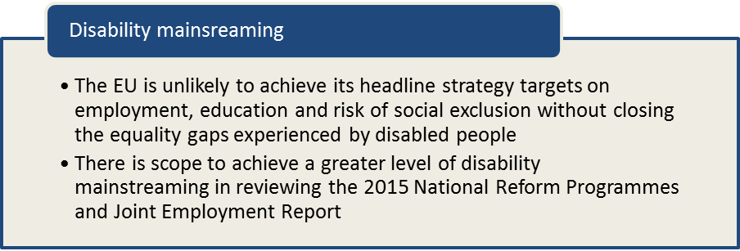

Considering high unemployment rates for low-skilled workers, the JER does acknowledge that ‘this is also true for third-country nationals and people with disabilities’ and that ‘for people with disabilities the unemployment rate is almost double the rate for people without disabilities’. However, the variation in disability employment gaps in different countries and the possible links with national economic and social policies should also be highlighted.

It notes that per capita social protection spending increased overall by 8 per cent between 2007 and 2011 and that ‘health and disability’ spending accounted for 32% of this increase (with spending on pensions for older people accounting for 44%) but with significant differences between Member States. Disability spending is thus presented as a significant challenge to the sustainability of social protection systems. Emphasising activation measures as a response, the Report suggests that:

Some Member States (Belgium, Estonia, Spain, Malta and the United Kingdom) have taken specific measures targeted to the population with higher risk of poverty notably youth, families with children or people with disabilities (Austria, Belgium, Cyprus, Finland, Ireland, Latvia, Sweden and the United Kingdom).

hese examples are cited in relation to ‘increasing efforts to strengthen ALMPs’ and with effort to create ‘targeted measures for those at higher risk of poverty’. However, it should be noted that in almost all cases such efforts have been directed to reduce disabled people’s eligibility for social protection measures by narrowing gateways or tightening criteria for financial assistance (although one example of increased monthly benefit for disabled people in Bulgaria is also mentioned).

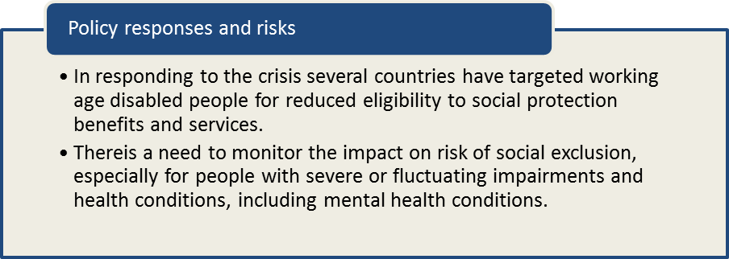

In considering this challenge, and the targeted policies, it is important to consider the diversity of social protection schemes afforded by the Member States and particularly those policies aimed towards people of working age who are at highest risk of low work intensity, poverty and social exclusion. The following sections provide some additional context when consulting the country reports and national policy frameworks.

Data on social protection spending is maintained by Eurostat in the ESSPROS system and most recently updated in November 2014. This distinguishes expenditure on ‘disability’ schemes from ‘sickness/health care’ schemes (as well as schemes relating to ‘old age’, ‘survivors’, ‘family/children’, ‘unemployment’, ‘housing’ and other ‘social exclusion’ functions). The disability function includes expenditure on disability pensions and early retirement benefits due to reduced capacity to work.

Overall expenditure on these ‘disability’ schemes can be represented as a proportion of GDP and tracked over time during the period of the economic crisis. Disability schemes (excluding expenditure on sickness/health care) accounted for an average of 2.1% GDP across the 28 EU Member States in 2012, and remained broadly static with an increase of just 0.1 percentage points in the five years since 2008. However, there is a wide range of variation in spending such schemes amongst the Member States, between Malta at 0.7% GDP and Denmark at 4.1% GDP in 2012. Belgium and Denmark have seen a 0.4 percentage point GDP increase in spending since 2008, while Sweden and Hungary saw a 0.5 percentage point decrease. However, it is important to note that social protection expenditure as a function of GDP may be also distorted by changes in overall GDP consequent on the crisis (e.g. in Ireland).

Figure 1: total expenditure on disability and sickness/health care schemes (as %GDP, 2012)
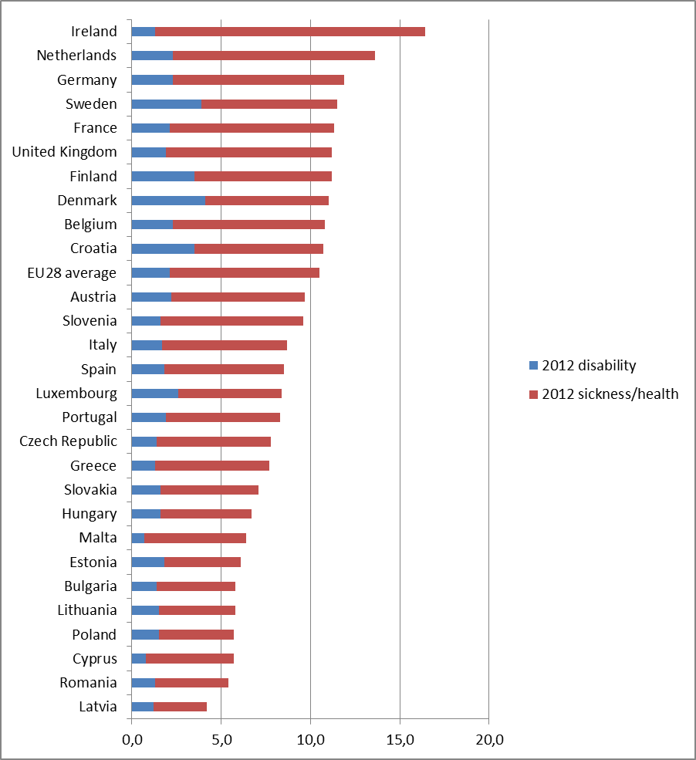
The Scandinavian welfare states (Denmark, Finland and Sweden) maintain the highest proportion of GDP expenditure on disability schemes, followed by Croatia and Luxembourg. The lowest proportional expenditures on disability schemes are Malta, Cyprus and Ireland.

As an alternative indicator, the following Table shows the level of per capita expenditure on disability and sickness/health schemes, which can be more easily compared between countries using common Purchasing Power Standards (PPS). This may be regarded as a crude measure of the generosity of disability and incapacity pensions in different countries, compared to expenditure on ‘sickness/health’ but it is important to caution that administrative definitions categorising national schemes may not be equivalent.
Figure 2: Expenditure on disability and sickness/health schemes (in PPS per head, 2012)
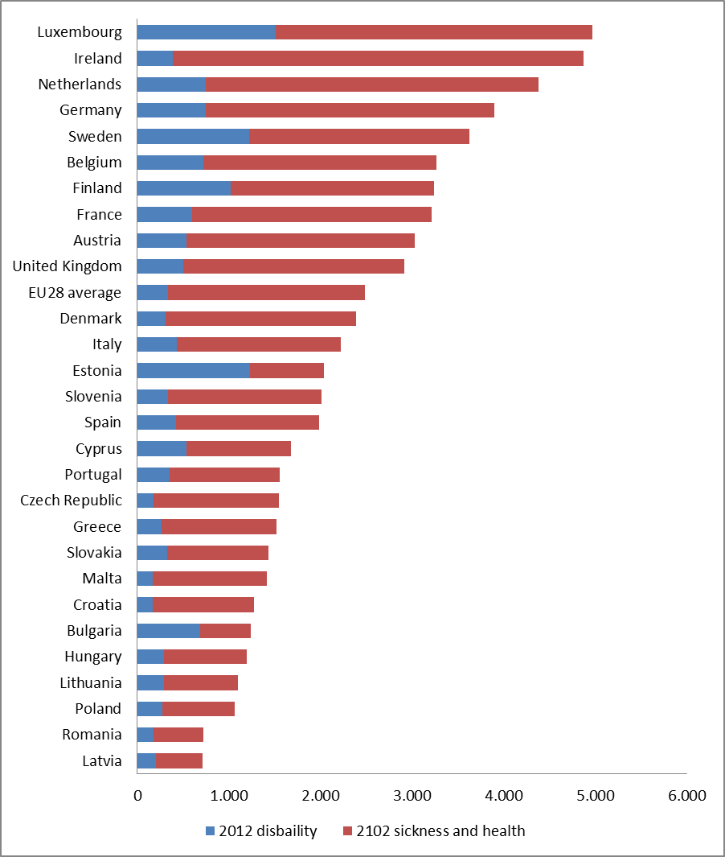
Source: Eurostat

On this measure, disability schemes in Luxembourg, Estonia, Sweden and Finland appear to present the highest relative purchasing power, followed by the Netherlands, Germany, Belgium and Bulgaria. Disability schemes appear to represent the least purchasing power in Romania, Croatia, Malta, Latvia and the Czech Republic. Thus, it is important to note that the proportion of GDP spent on pensions is not closely correlated with the presumed purchasing power of those benefits in each country.

The following table presents the purchasing power standard value of cash benefits within disability schemes (i.e. excluding benefits in kind), and distinguishes the proportion reported as means-tested in each country. This illustrates how, in general across the EU, the value of disability and incapacity pensions remains non-means tested (although with significant means-tested components in Ireland, Germany, Belgium, France and the United Kingdom). There is great variation in the levels of cash benefit available. For example, the assumed per capita purchasing power of disability pensions in Denmark is almost 22 times the value of disability pensions in Bulgaria (although this is merely illustrative and does not take into account the mix or combination of social protection that may be available to disabled adults).

Figure 3: Value and means-testing of disability pensions in 2012 (in PPS)
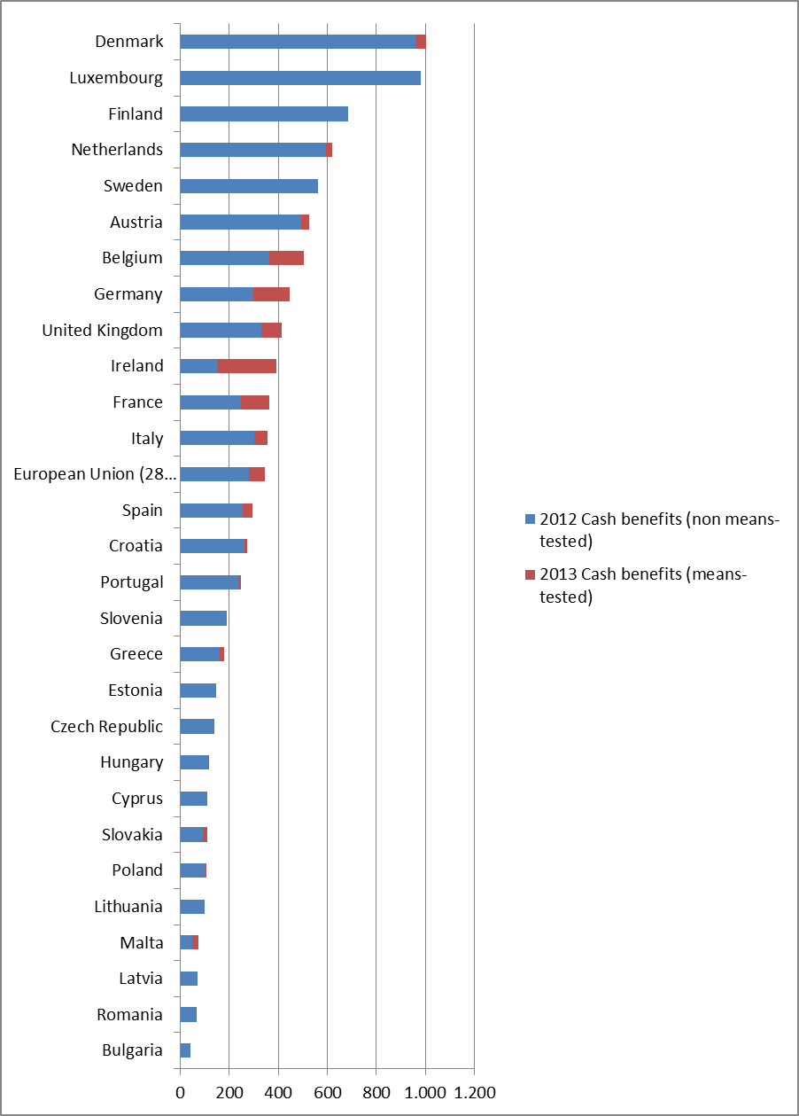
As noted earlier, there is some association between the disability equality gaps evident in the headline data and the level of social protection available to disabled people in different countries, as well as the extent of other equality gaps at the national level (e.g. gender equality gaps or income equality gaps between rich and poor). Further analysis is required to explore these associations in more detail and to identify the combinational policy interventions that are associated with narrowing disability equality gaps. This kind of critical policy analysis would assist in informing country specific commentaries and recommendations in the future.

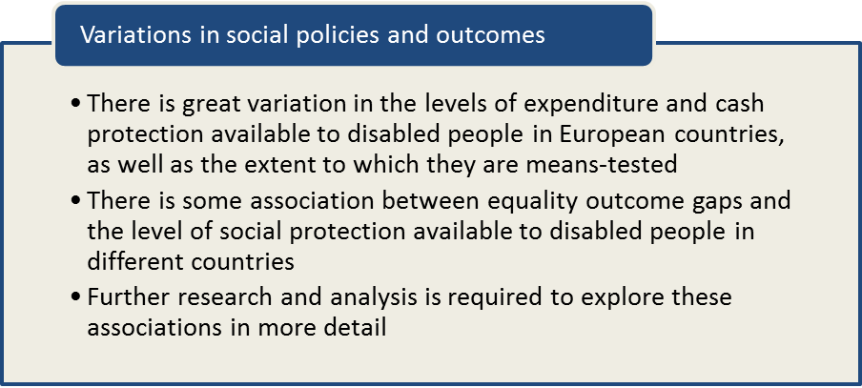

Recommendations

- Investment proposals under the new European Social Investment Fund (ESIF) should not be judged 'credible' unless they offer inclusion and accessibility disabled people.
- Social investors should be encouraged to invest in making major infrastructures more accessible to disabled people, including transport, broadband and education systems.
- The EU2020 headline indicators should be matched by national disability equality indicators and targets in the National Reform Programmes of the Member States.
- Member States should include disability identifier questions in all major social surveys, including their national Labour Force Survey questionnaires.
- The Member States and the European Agency should be encouraged to develop and utilise administrative data sources to indicate the situation of young disabled people in relation to education and training.
- Close attention is needed to monitor the impact of structural reforms and fiscal consolidation on poverty and social exclusion for people with severe and fluctuating impairments and health conditions, including mental health conditions.
- New research studies are needed to explore the associations between disability equality gaps and national policy regimes.

In terms of the preliminary ANED country reports (December 2014), the following recommendations were identified.

COUNTRY
Austria | Disabled people are not often considered as a distinct target group in policy documents. Disability policy is considered as one sub-chapter of social policy, rather than as a distinct policy field.  Measures are mostly developed by the individual provinces (Lander), which makes harmonised governance difficult.  Need to include disabled people of all ages in data collection and analysis.  A microcensus with a focus on disabled people is in preparation by the Ministry of Labour, Social Affairs and Consumer Protection, and Statistics Austria for 2015. Disabled people and researchers from the disability field need to be included in discussions.
Belgium | Belgium should encourage universities to think beyond basic accessibility and simple adjustments and develop best practices for including students with disabilities in higher education.  Belgium should launch a campaign on the right to work of disabled people directed towards companies and the general public.  Belgium should ensure better coordination between disability allowance, income replacement and ‘normal’ income for disabled people in a way that avoids disincentives and guarantees coherence.
Bulgaria | New disability legislation is needed to implement UN CRPD, including reforms in disability assessment procedures, individual supports, and availability of technical aids.  Accessibility of the environment remains an issue, though legislation is in place. Monitoring of new and existing constructions should be strengthened.  Funding for long-term care should allow disabled people greater choices for community living as well as residential care. A reduction in residential placements requires investment in accessible and affordable housing, and in personal assistance services, including peer support schemes. ESIF could be used as a stimulus to develop such options.  A parallel transfer of investment from segregated schooling to accommodation in mainstream educational provision is also needed.  Support for employers of disabled people should be balanced with personalised supports for disabled workers on the basis of individual assessment for specific job performance in the open labour market, as opposed to the current practice of opening ‘special’ jobs for disabled people.  Disability specific data should be collected all relevant Ministries to monitor their policies from a disability perspective. The Agency for Disabled People provides a basis for cross-sectoral policy development between Ministries and could be strengthened to provide leadership in developing more personalised and rights-based disability initiatives.
Croatia | Investment is needed to achieve structural reforms, notably in accelerating deinstitutionalisation from residential long-term care placements. ESIF could be usefully targeted to stimulate community-based living options and support services.  Investments should also be made in developing supports for educational integration, for example through teaching assistants.  There is a need to stimulate independent evaluation of policy reforms, such as the implementation of new education strategy, challenges of new pension system, new rehabilitation procedures, new social and medical care procedures. These reforms present significant administrative challenges that would benefit from independent research and lesson learning from other EU Member States.
Cyprus | Reliable evidence-based information on the implementation of rights-based disability policies is needed, including research and evaluation independent of the Department of Social Inclusion for People with Disabilities.  A critical overview of the existing legislative and policy context for disability policy in Cyprus is needed.
Czech Republic | With regards to active employment policy, attention should be given to supporting disabled people in the open labour market, including the expansion of individualised counselling services.  Preparatory work on the legal framework for the complex rehabilitation system should be renewed and completed.  The right to support for disabled students in tertiary education should be established in the Tertiary Education Act.  The growing trend in risk of household poverty amongst disabled households should be further analysed and relevant poverty reduction measures introduced.
Denmark | It is unclear whether recent market-based welfare reforms will provide adequate social protection for disabled people, for example in relation to incentive benefits in education or rehabilitation. It will be important to monitor the evolution of poverty risk in Denmark from a disability perspective, for which targeted data analysis is needed and in comparison with other EU Member States.
Estonia
Finland | Further data is needed on the employment/unemployment situation of disabled people in Finland, as well as more detailed and disaggregated statistical data on the situation of disabled people more generally.  Equality in education should be improved, including consideration of the dual system of education that reproduces discrimination. There is scope to invest also in supportive teaching and to address administrative barriers to inclusion.
France
Germany | ‘Equal opportunities for all’ should have a high priority on the national ESIF agenda and funded projects should be obliged to consider disability as an explicit issue in monitoring.
Greece | There is a need for better data on disability and employment to support policy measures for this group, distinctively from other ‘vulnerable social groups’. Disability targets should be included in national employment action plans as well as guidelines and compliance mechanisms for Equality Law 3304/2005 (combating discrimination in employment).  Participation in ALMPs could be increased with investments in outreach actions and personalised support services based on individual access needs, as well as investments in reasonable accommodation in workplaces.  Participation in general education could be increased by investing in accessibility of mainstream school buildings as well as through guidelines on implementing inclusive education, in respect of UNCRPD principles and international best practices.  There is potential to establish/enhance accessibility units in tertiary educational settings, learning from best practices nationally and internationally, and to engage disabled students in evaluation studies that consider their learning experiences.  The disability dimension must be included in national statistics on poverty and material deprivation. Further research is needed into household living conditions and to establish the additional living costs associated with disability.  Any rationalisation of resources in welfare reform should be based on needs assessment, rather than impairment diagnosis alone, and taking account of environmental factors (i.e. adopting a definition of disability more aligned with the UNCRPD).  Accessibility for disabled people should be among the guiding principles for selecting actions funded via ESIF. Such funds could also be used to promote independent living through targeted support services, including personal assistance schemes, and quality monitoring systems for such schemes.
Hungary | Investment priorities in support of disabled people’s employment, including the allocation of ESIF, should be shifted from public work towards active labour market programs.  There is a need for government action to target early school leaving with special focus on young disabled people and to elaborate policy programmes that mitigate their risk.  Stimulus is needed to promote an increase in access to Universities for disabled students, for example via a quota system or funding incentive scheme.
Ireland | As Ireland continues to rebuild its economy and implement the Country Specific Recommendations that promote efficiency and reform of social institutions it is essential that the rights and social protection of disabled people are considered at every step.  Ireland should be encouraged to ratify the CRPD as soon as the reform of legal capacity legislation is passed, which is anticipated in 2015. To support its implementation, there is a need for improved data collection on education, employment, poverty and social inclusion, including disaggregation of data based on disability.  Disability also needs to be better mainstreamed in Departmental plans for employment, poverty and education and linked to the National Disability Strategy. The 2014 Specialist Training Programme in the Further Education and Training Plan is one example where segregated approaches to service design persist.  Full implementation of the EPSEN act would provide disabled students with support to succeed in school and enable them to be better prepared for transition to tertiary education or employment.
Italy
Latvia | No specific recommendation regarding policies.  There is a necessity to provide more reliable statistics and data on the situation of disabled people in Latvia to support policy monitoring and development.
Lithuania
Luxembourg | A differentiated education system based on age norm performance measures makes it difficult to implement inclusive mainstream schools. This is complicated by the language learning expectations arising from Luxembourg’s multi-lingual context. A broad discussion is needed to establish how educational opportunity can be achieved for disabled students in line with CRPD.  Although Luxembourg is amongst the wealthiest of EU countries, poverty gaps have increased with risks to social cohesion. It is important to establish how this is affecting disabled households in terms of earnings and social protection.
Malta | The past focus of investment in employment activation, including the use of EU Structural Funds, has been on training disabled people in employability skills but with limited outcomes in terms of actual employment. There is a need to broaden the approach and also develop measures that encourage employers to recruit and retain disabled employees.  There is also a need to ensure reasonable accommodation for disabled students who are following lifelong education and ad hoc training opportunities, as well as developing accessibility in workplaces.  There is a need for statistical data regarding early school leavers with disability as well as data on disability and poverty risks. The finalised National Policy on the Rights of Persons with Disabilities should seek to establish disability-specific outcome targets with supporting data indicators.  There is a need for greater synergy between disability-specific measures and mainstream strategies aimed at increasing education and employment opportunities and reducing poverty.
Netherlands | Young disabled people are clearly visible in benefit statistics and statistics for special education. Because their number grew rapidly in the past decade there has been a major incentive for labour market policy reform, notably in eligibility criteria for benefits and long term care. However the same group is largely excluded from surveys on participation, inclusion and poverty, especially in the case of people with intellectual impairments or mental health conditions.  It is important that adequate data collection and monitoring is put in place to establish the impact of the reforms on these high risk groups. There is a risk that dependency on state disability benefit may be simply transferred to dependency on household/family members or basic means-tested income protection.  There is a need to establish whether people with intellectual impairments and mental health conditions receive sufficient support when entering vocational education, or the open labour market now that entry into sheltered workplaces has been ended.
Poland
Portugal | While fiscal control and competitiveness continue to be important goals Portugal needs stronger measures that tackle disability discrimination, particularly in the areas of education, employment, social care and pensions as well as supports to independent living. Disability needs to be mainstreamed in all areas of policy.  ESIF provides important opportunities for strategic investments during a period of national spending constraint. The prioritisation of investments in support of social inclusion for disabled people is needed.  The Operational Programmes should promote the removal of barriers, inclusive design and promotion of accessibility in the built environment and transportation systems as an enabler to labour market participation for disabled people.  Funds should be allocated to strengthen supports for initial and lifelong vocational training and transition to the labour market. They could also be used to support inclusive education, as a strategy to prevent early school-leaving, and completion of tertiary education by disabled students (supported by requirements that post-secondary institutions provide appropriate accommodations).  The Operational Programme Social Inclusion and Employment, should to support the development and implementation of personal assistance schemes.  There is concern relating to poverty risk and there is a need to examine low levels of disability-related benefits to establish if they provide adequate protection from poverty risk.
Romania
Slovakia | Slovakia continues with its systematic effort to set out programmatic, strategic and legislative rules to improve non-discrimination and living conditions for disabled people but there is a need to clearly distinguish a disability perspective from other marginalised groups.  There is a need to develop indicator-based methodologies monitor and evaluate the implementation and impact of programs and measures.
Slovenia | In the current climate of fiscal consolidation there is an urgent need to consider the situation of disabled people and their risk of social exclusion.  There is a need for measures to stimulate job growth for young disabled people, as well as older disabled workers and disabled people in general.  The failure of public sector salaries and pensions to keep pace with inflation and living costs adds risk to already marginalised groups and raises the risk of poverty.  Specifically, the plan to reduce social welfare expenditure in 2014-2018 below 15% of governmental spending must be assessed for its equality impact on disabled people’s poverty risk.  Improvement in access to and accessibility of health services are also needed.
Spain | There is a lack of specific data on the educational, employment, poverty and social situation of disabled people in Spain and its regions. A cross-departmental approach is needed to establish common indicators and a systematic approach, including longitudinal data collection to monitor policy achievements over time.  Outcome indicators should be determined at both national and regional levels, allowing the examination of existing situations and the relationship between public programs and policies and their outcomes.  Independent studies are also needed on the outcomes of programs and actions for disabled people, including user satisfaction.
Sweden | More than a quarter of registered jobseekers are disabled and it is essential that their needs are prioritised in the review of public employment services.  There is potential to enhance and simplify the wage subsidy scheme to further incentive employers by raising the maximum.  There is a need to address accessibility in schools as a factor in raising retention and transition to tertiary education. The Swedish National Agency for Education should require schools to report on accessibility.  There is a need to accelerate implementation of accessible transport systems as gateway to employment and educational participation for disabled people but there remains a lack of clarity concerning the responsibilities of different actors.  The Swedish municipalities provide much of the social support that disabled people depend upon. Agreement between the Government and the Swedish Association of Local Authorities and Regions (SKL) on disability policy implementation would clarify how progress can be made in long-term support.
United Kingdom | There is an urgent need to respond to the concerns raised in independent reviews about the effectiveness, efficiency and fairness of new assessment processes for conditional disability benefits – notably in relation to the Work Capability Assessment gateway to Employment Support Allowance the functional capability assessments gateway to Personal Independence Payments.  Benefits that compensate the ‘additional’ costs of living associated with disability are not included in benefit cap calculations and should be treated as additional to calculations of income norms in statistical calculations of poverty risk and means-testing criteria for income-related benefits.  The national disability strategy is cross-sectoral and there is a need to similarly spread European Structural Funds, beyond relatively ineffective investments in individual skills development and towards investments in accessibility – e.g. in relation to Objective 2 (information and communication technologies) and Objective 7 (sustainable transport and infrastructures) as wells as workplace accessibility and housing supply, whilst avoiding investments in institutionalised forms of housing support.  The courts have ruled against the UK Government in significant cases of reform where insufficient consideration was given to the Public Sector Equality Duty. For example, Equality Impact Assessment requirements need to be considered in relation to the National Infrastructure Plan and the roll out of Universal Credit.

COM(2014) 902 final http://ec.europa.eu/europe2020/pdf/2015/ags2015_en.pdf.
http://ec.europa.eu/priorities/jobs-growth-investment/plan/docs/factsheet1-why_en.pdf.
http://ec.europa.eu/priorities/jobs-growth-investment/plan/docs/factsheet3-what-in_en.pdf.
http://ec.europa.eu/social/BlobServlet?docId=13093&langId=en.
http://eur-lex.europa.eu/LexUriServ/LexUriServ.do?uri=COM:2010:2020:FIN:EN:PDF.
http://ec.europa.eu/europe2020/europe-2020-in-a-nutshell/targets/index_en.htm.
http://epp.eurostat.ec.europa.eu/portal/page/portal/europe_2020_indicators/headline_indicators.
http://ec.europa.eu/europe2020/pdf/targets_en.pdf.
These are presented annually by ANED within the framework of ‘Indicators of Disability Equality in Europe’ by presenting data for women and men identified in EU-SILC data as having ‘limitations in the activities people normally do’ due to a long-term health condition or disability. http://www.disability-europe.net/theme/statistical-indicators. Parallel data is now also presented via the new Eurostat ‘Disbaility’ database: http://epp.eurostat.ec.europa.eu/portal/page/portal/health/disability/data/database.
EUSILC UDB 2012 – version 2 of August 2014.
The SILC survey questions are contained in the Minimum European Health Module (MEHM) http://epp.eurostat.ec.europa.eu/statistics_explained/index.php/Glossary:Minimum_European_Health_Module_(MEHM).
See page 27 of the November 2014 draft ANED report European comparative data on Europe 2020 & People with disabilities.
See page 75 of the November 2014 draft ANED report European comparative data on Europe 2020 & People with disabilities.
For the LFS AHM data see, Early school leavers http://appsso.eurostat.ec.europa.eu/nui/show.do?dataset=hlth_de010&lang=en and tertiary educational attainment http://appsso.eurostat.ec.europa.eu/nui/show.do?dataset=hlth_de020&lang=en.
See page 206 of the November 2014 draft ANED report European comparative data on Europe 2020 & People with disabilities.
http://ec.europa.eu/social/BlobServlet?docId=13093&langId=en.
Page 4, footnote 2.
Page 20 and Figure 14.
Page 33.
http://epp.eurostat.ec.europa.eu/portal/page/portal/social_protection/data/database.
http://epp.eurostat.ec.europa.eu/statistics_explained/index.php/Glossary:Purchasing_power_standard_%28PPS%29.
http://epp.eurostat.ec.europa.eu/portal/page/portal/social_protection/data/database.

